REQUIREMENTS ANALYSIS DOCUMENT

- Introduction
The “Language Learning App with Object Recognition” is a mobile application designed to improve vocabulary skills for language learners, using object recognition technology to display corresponding foreign language words of objects using camera. The system's objectives are to collect a large dataset of images, develop a CNN-based deep learning model for object recognition, and integrate it into the application. The project's success will be determined by the accuracy of the recognition model. The application aims to support multiple languages, have a simple user interface, and provide a responsive user experience.

  - Purpose of the System
The purpose of the “Language Learning App with Object Recognition” is to provide an interactive and engaging platform for language learners to improve their vocabulary skills in a foreign language by using object recognition technology. The application will be useful especially for language learners who has visual memory. The system aims to enhance the user's learning experience by providing a visual aid to learn new words and boost their confidence in using a foreign language.

  - Scope of the System
The scope of the “Language Learning App with Object Recognition” includes collecting a large dataset of images with common objects, preprocessing and labeling the dataset, developing a deep learning model based on CNNs to recognize objects, and integrating the trained model into a mobile application written with Flutter. The application will use the mobile device's camera to capture images of objects, display the corresponding vocabulary word in the user's selected foreign language, and also include a text-to-speech feature to improve the user's pronunciation skills.

  - Objectives and Success Criteria of the Project
The main objective of the project is to develop an efficient deep learning model that can accurately recognize and classify objects within captured images from camera to enhance the user's learning experience. The success criteria of the project will be based on the accuracy of the object recognition model and the user's feedback on the application's usability and effectiveness in improving their vocabulary skills. The application should also be able to support multiple languages, have a simple and intuitive UI, and provide a smooth and responsive user experience.

  - Definitions, Acronyms, and Abbreviations
Acronyms:

CNN: Convolutional neural network
TTS: Text-to-speech
UI: User interface
UX: User experience
API: Application Programming Interface
SDK: Software Development Kit
GPU: Graphics Processing Unit
CPU: Central Processing Unit

Abbreviations:

App: Application
DL: Deep Learning
UI/UX: User Interface/User Experience
AI: Artificial Intelligence
  - Overview
The Requirements Analysis Document (RAD) outlines the proposed system for the Language Learning App with Object Recognition. The RAD is divided into two main sections: the introduction and the proposed system.

The introduction provides an overview of the system and defines key terms, acronyms, and abbreviations used throughout the document. It also includes the purpose, scope, objectives, and success criteria of the project.

The RAD is organized into sections that describe the purpose, scope, and objectives of the project, as well as the proposed system's components and functionality. The functional and non-functional requirements are also outlined, along with any assumptions or constraints that may impact the development of the system. It describes the scenarios, use cases, object model, and dynamic models for the system.

- Proposed System
  - Overview
The Language Learning App with Object Recognition system is composed of two main components: a mobile application and a deep learning model.

The mobile application serves as the user interface, allowing language learners to interact with the system. It utilizes the mobile device's camera to capture images of objects and displays the corresponding foreign language vocabulary words for recognized objects. The application also provides a text-to-speech feature to improve the user's pronunciation skills.

On the other hand, the deep learning model is responsible for object recognition and classification. It is based on convolutional neural networks and is trained on a large dataset of images with common objects from different categories such as fruits, vegetables, animals, and furniture. The model is optimized for accuracy and performance to ensure that it can accurately recognize and classify objects within images. These two components work together to provide a comprehensive and engaging language learning experience for the user.
  - Functional Requirements
1. The application should be able to capture images of objects using the mobile device camera.
2. The application should be able to recognize objects from the images using a deep learning model based on convolutional neural networks.
3. The application should display the corresponding vocabulary word in the user's selected foreign language for the recognized objects.
4. The application should allow users to select a foreign language from a list of available languages.
5. The application should provide a text-to-speech feature to pronounce the vocabulary words in the selected foreign language.

  - Nonfunctional Requirements
- The application should have a fast and responsive user interface to provide a smooth user experience.
- The application should be available on both iOS and Android platforms.
- The application should be optimized for performance and able to handle a large number of images and vocabulary words.
- The application should have a simple and intuitive design to be user-friendly.
- The application should be lightweight and not consume too much storage space on the user's device.
- The application should be easy to navigate and intuitive to use, with clear instructions and user guides.
- The application should have a low error rate for object recognition and vocabulary word translation.

    - Usability
It aims to help users learn new vocabulary in a foreign language through object recognition and interactive mobile application, using a deep learning model and text-to-speech feature.
    - Reliability
The reliability of the project will depend on the quality of the dataset used to train the deep learning model, as well as testing and optimization of the application for performance and user experience.
    - Performance
The performance of the project will depend on the accuracy and speed of the deep learning model for object recognition, as well as the responsiveness and efficiency of the mobile application.
    - Supportability
The application should be available on both iOS and Android platforms.
    - Implementation
The project will require adherence to software engineering best practices and standards for scalability, maintainability, security, and user privacy.
    - Interface
The interface of the project should be user-friendly, intuitive, and aesthetically pleasing to enhance user experience and promote engagement.
    - Packaging
The application should provide easy installation, deployment, and distribution of the application across multiple mobile platforms and devices.

    - Legal
The legal requirements for the project include compliance with intellectual property laws, data protection regulations, and user privacy policies.

    - Other constraints:
Business: The app can be monetized through in-app purchases, subscription-based models, or targeted advertising. It can also increase the competitiveness of language learning apps in the market and attract more users.
Social: The app can have a positive impact on people's lives by providing an innovative and interactive way of learning a new language and improving their vocabulary skills. It can address the needs of language learners who have visual memory and prefer interactive learning experiences. However, it may not be suitable for those who prefer traditional classroom settings or auditory learning methods.

  - System Models
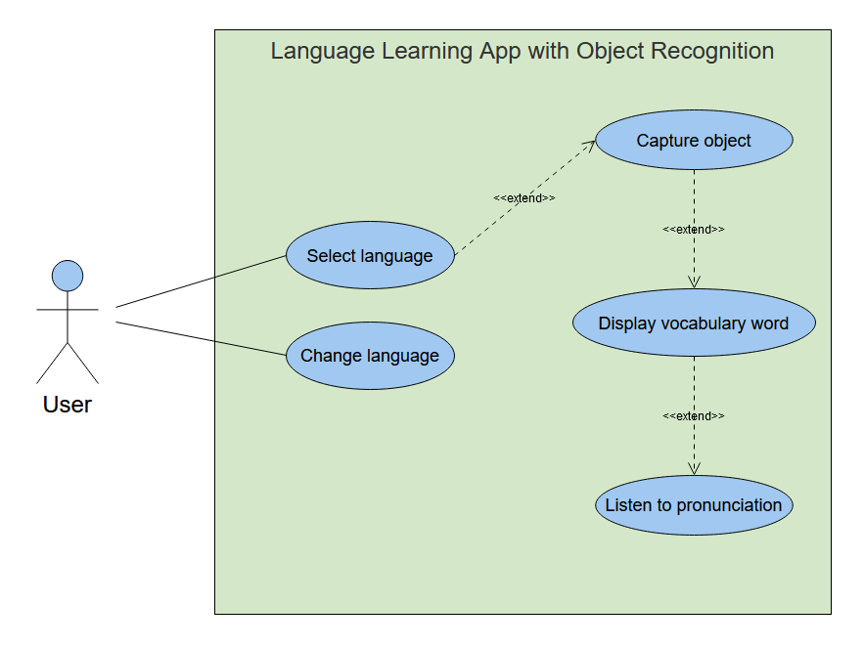
    - Scenarios
- Mary, a language learner, downloads the "Learn Language with Object Recognition App" on her smartphone and selects French as her target language.
- She opens the app and points her camera at an apple. The app recognizes the apple using the pre-trained deep learning model and displays the corresponding French word for "apple" (pomme) on the screen.
- Mary taps on the word to hear its pronunciation via the app's text-to-speech feature. She repeats the word a few times until she feels confident with its pronunciation.
- Next, Mary points her camera at a chair. The app recognizes the chair and displays the corresponding French word for "chair" (chaise) on the screen.
- Mary taps on the word to hear its pronunciation and repeats it a few times until she feels confident with its pronunciation.
- Mary continues to use the app to learn new vocabulary words and improve her French language skills. She finds it helpful that she can use the app anytime and anywhere, making language learning convenient and accessible.
- The app's performance is fast and accurate, making Mary's learning experience seamless and enjoyable. She recommends the app to her friends who are also learning foreign languages.
    - Use case model
Actors:
- User: A language learner who wants to improve their vocabulary skills in a foreign language.
Preconditions:
- The user has downloaded and installed the " Language Learning App with Object Recognition" on their mobile device.
- The user has selected a foreign language they want to learn.
Basic Flow:
- The user opens the app.
- The app activates the mobile device's camera.
- The user points the camera at an object.
- The app recognizes the object using a pre-trained deep learning model.
- The app displays the corresponding vocabulary word in the user's selected foreign language on the screen.
- The user can tap on the word to hear its pronunciation via the app's text-to-speech feature.
- The user can repeat the word a few times until they feel confident with its pronunciation.
- The user can continue to use the app to learn new vocabulary words and improve their foreign language skills.
Alternative Flows:
- If the app fails to recognize the object, it displays an error message and prompts the user to try again.
- If the user wants to switch to a different foreign language, they can do so in the app's settings.
Postconditions:
- The user has learned new vocabulary words in their selected foreign language using the app.
- The app has provided a convenient and accessible way for the user to improve their foreign language skills.
    - Object model
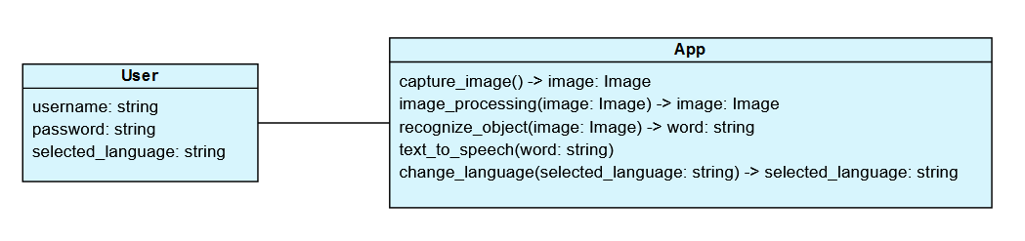
    - Dynamic model
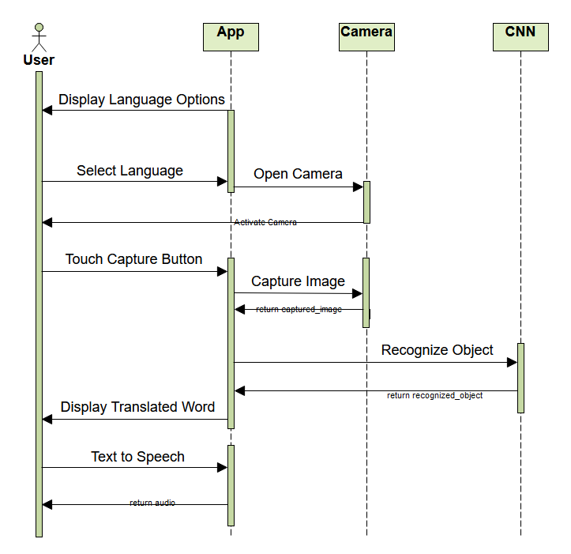
    - User interface—navigational paths and screen mock-ups

- Glossary
- Object recognition: The process of identifying and classifying objects within digital images or videos using computer vision techniques. [1]
- Deep learning: A subset of machine learning that uses artificial neural networks with multiple layers to learn and make predictions from data.
- Convolutional neural networks (CNNs): A type of neural network that is commonly used for image recognition and processing tasks. CNNs learn to recognize patterns and features within images by applying filters and pooling operations.
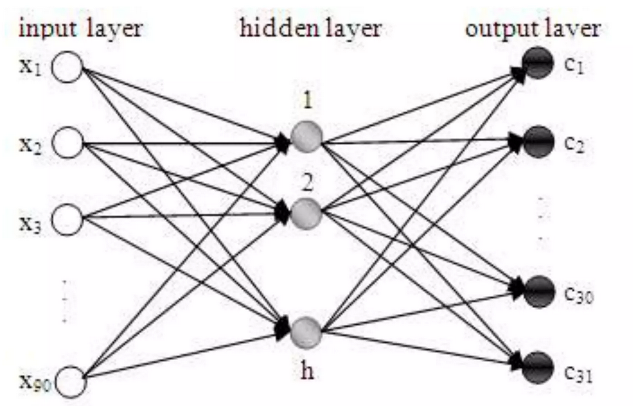
- Image preprocessing: The process of preparing digital images for further analysis or processing by applying techniques such as resizing, cropping, normalization, and filtering.
- Text-to-speech (TTS): A technology that converts written text into spoken words using computer-generated voices.
- User interface (UI): The visual and interactive elements of a software application or website that allow users to interact with and control the system.
- User experience (UX): The overall experience and satisfaction that users have when using a software application or website.

- References
- Elgammal, Ahmed "CS 534: Computer Vision 3D Model-based recognition", Dept of Computer Science, Rutgers University

